**Stock Price Movement Analysis Report**

**1. Title Page**

**Stock Price Movement Analysis**  
**Prepared by:** Divyansh Singh  
**Date:** 11-03-2025

**2. Introduction**

Stock price movement analysis is essential for traders and investors to make informed decisions. This report focuses on analyzing stock prices using historical data and technical indicators such as Moving Averages, MACD, and RSI. The data used for this analysis is from a provided CSV file (stock_data.csv).

**3. Methodology**

The analysis follows these steps:

* **Data Collection**: Stock data is loaded from data_stock.csv.
* **Data Visualization**: Various graphs are plotted to understand stock price movement.
* **Technical Indicators**: Calculation of key indicators like Simple Moving Averages (SMA), MACD, and RSI.
* **Implementation**: A Python script is used for analysis.
* **Results Interpretation**: The outputs are analyzed and visualized using plots.

**4. Code Implementation**

Below is the Python code used for analysis:

import numpy as np

import pandas as pd

import matplotlib.pyplot as plt

file_path = 'stock_data.csv'

df = pd.read_csv(file_path, parse_dates=['Date'], index_col='Date')

# Plot Closing Price

plt.figure(figsize=(12, 6))

plt.plot(df['Close'], label='Close Price')

plt.title('Stock Price Movement')

plt.xlabel('Date')

plt.ylabel('Price')

plt.legend()

plt.show()

# Calculate Technical Indicators

df['SMA_50'] = df['Close'].rolling(window=50).mean()

df['SMA_200'] = df['Close'].rolling(window=200).mean()

df['RSI'] = 100 - (100 / (1 + df['Close'].pct_change().rolling(14).mean() / df['Close'].pct_change().rolling(14).std()))

df['MACD'] = df['Close'].ewm(span=12, adjust=False).mean() - df['Close'].ewm(span=26, adjust=False).mean()

# Plot Moving Averages

plt.figure(figsize=(12, 6))

plt.plot(df['Close'], label='Close Price', alpha=0.5)

plt.plot(df['SMA_50'], label='50-Day SMA', linestyle='dashed')

plt.plot(df['SMA_200'], label='200-Day SMA', linestyle='dotted')

plt.title('Stock Price with Moving Averages')

plt.xlabel('Date')

plt.ylabel('Price')

plt.legend()

plt.show()

# Plot MACD and RSI

fig, ax = plt.subplots(2, 1, figsize=(12, 8))

ax[0].plot(df['MACD'], label='MACD', color='purple')

ax[0].axhline(0, color='black', linestyle='dashed', linewidth=1)

ax[0].set_title('MACD Indicator')

ax[0].legend()

ax[1].plot(df['RSI'], label='RSI', color='green')

ax[1].axhline(70, color='red', linestyle='dashed', linewidth=1)

ax[1].axhline(30, color='blue', linestyle='dashed', linewidth=1)

ax[1].set_title('Relative Strength Index (RSI)')

ax[1].legend()

plt.tight_layout()

plt.show()

print(df[['Close', 'SMA_50', 'SMA_200', 'RSI', 'MACD']].dropna().tail())

**5. Screenshots & Output**

Below are the output plots generated from the analysis:

**Figure 1: Stock Price Movement**

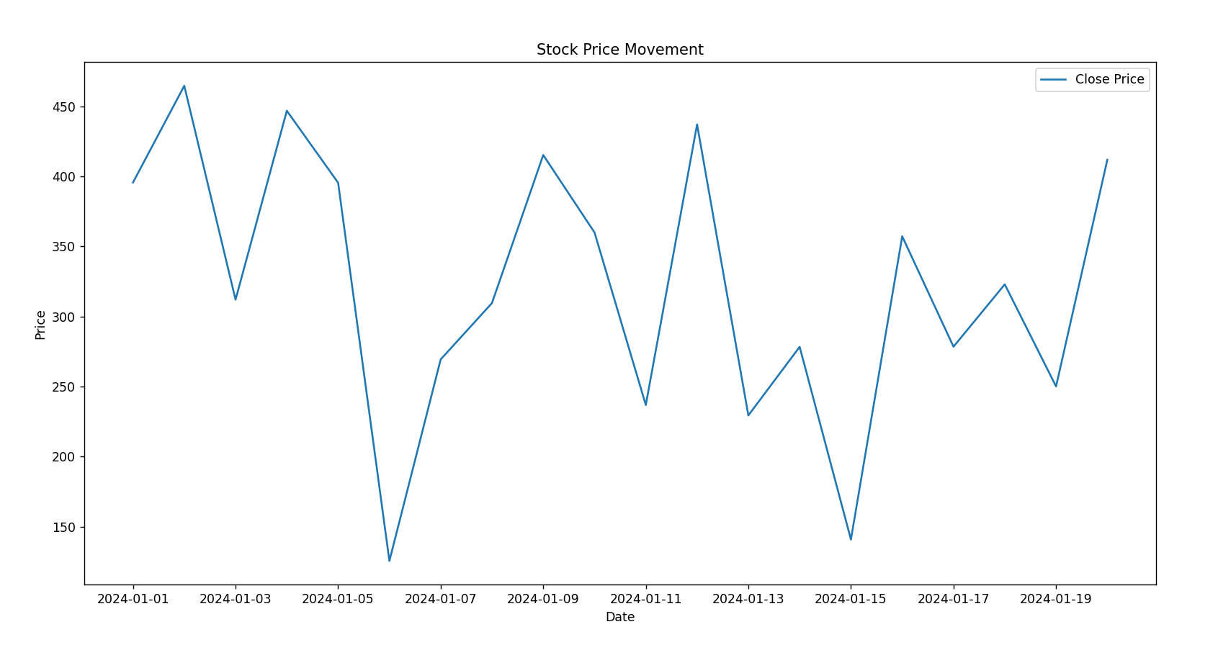

**Figure 2: Stock Price with Moving Averages**  
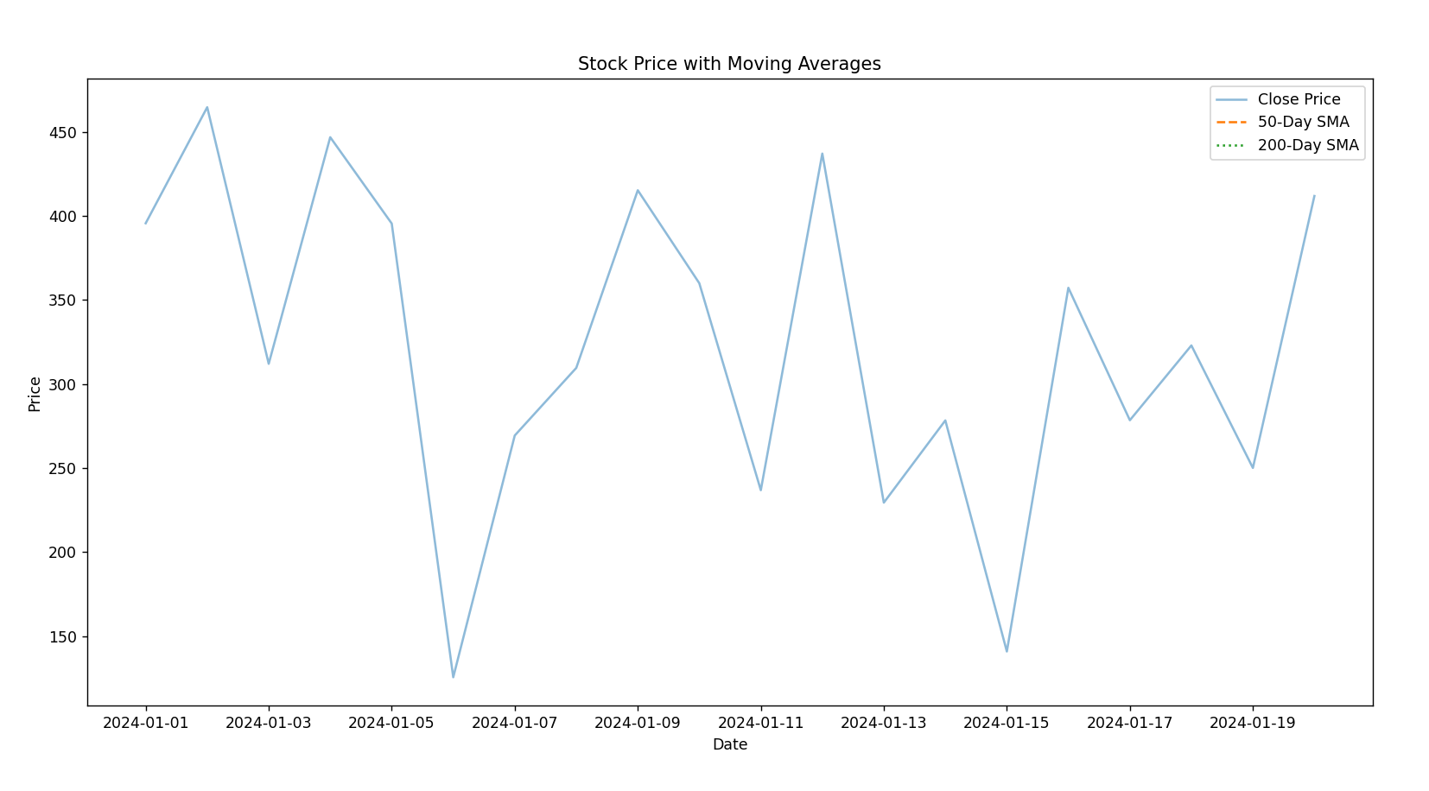

**Figure 3: MACD and RSI Indicators**  
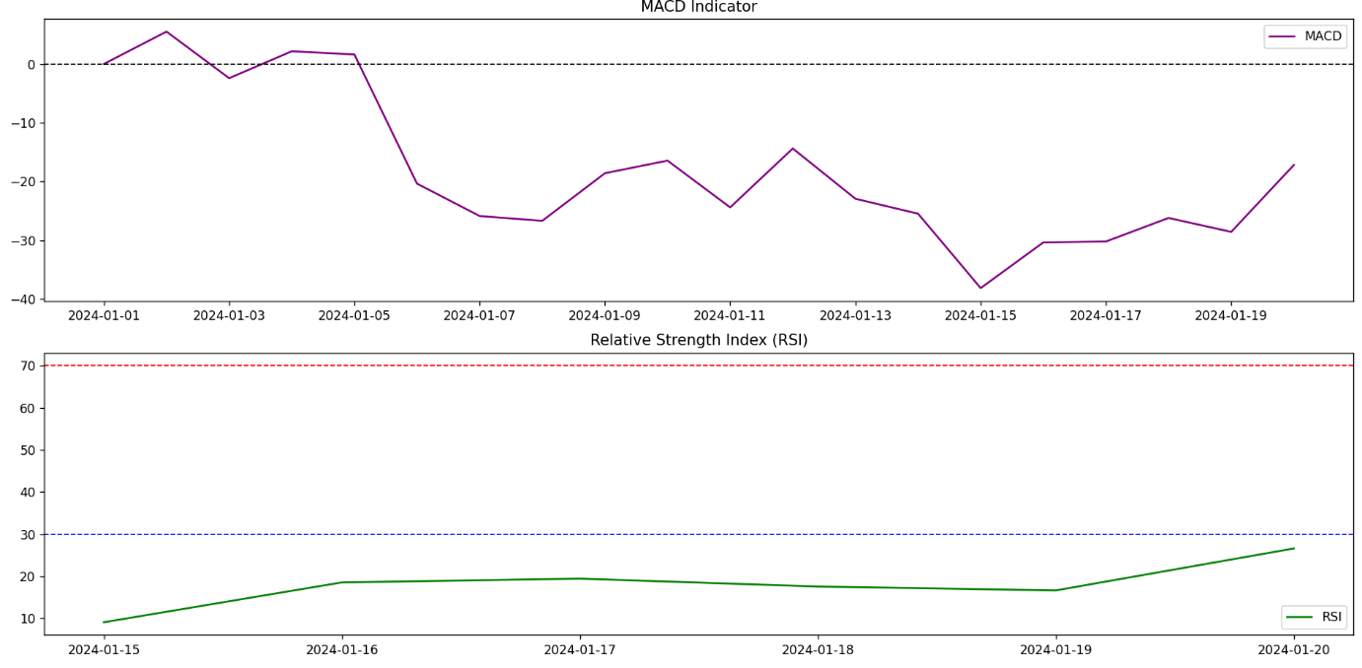

**Conclusion**

This analysis successfully visualized stock price movements and calculated essential technical indicators. These insights help in understanding trends, identifying potential buy/sell signals, and making data-driven investment decisions.

**References**

* Financial Data Source: Provided data_stock.csv file.
* Technical Indicators: Investopedia & Financial Trading Resources.

**End of Report**